Chapter 15, Solution 21.

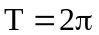

Let 